**Lesson 3: Calculating Limits Using Limit Principles**

After completing this lesson, you should be able to

* discuss limit principles
* discuss limit theorems

**Commentary**

**Topics**

1. [Limit Principles](https://content.umuc.edu/file/7bdece95-b196-4233-9313-aa904663b08e/1/MATH140-0909.zip/Modules/M2-Module_2/Lesson_3/S3-Commentary.html#I)
2. [Limit Theorems](https://content.umuc.edu/file/7bdece95-b196-4233-9313-aa904663b08e/1/MATH140-0909.zip/Modules/M2-Module_2/Lesson_3/S3-Commentary.html#II)

**1. Limit Principles**

Theorem 1 Limit Principles (*x* approaches *c*)

Suppose lim(*x*+*c*) *f*(*x*) and lim(*x*+*c*) *g*(*x*) both exist. The following then are true:

|  |  |
| --- | --- |
| 1. Sum Principle: | https://content.umuc.edu/file/7bdece95-b196-4233-9313-aa904663b08e/1/MATH140-0909.zip/Modules/M2-Module_2/Lesson_3/images/limit-x-to-c.gif [*f*(*x*) + *g*(*x*)] = https://content.umuc.edu/file/7bdece95-b196-4233-9313-aa904663b08e/1/MATH140-0909.zip/Modules/M2-Module_2/Lesson_3/images/limit-x-to-c.gif*f*(*x*) + https://content.umuc.edu/file/7bdece95-b196-4233-9313-aa904663b08e/1/MATH140-0909.zip/Modules/M2-Module_2/Lesson_3/images/limit-x-to-c.gif*g*(*x*) |
| 2. Difference Principle: | https://content.umuc.edu/file/7bdece95-b196-4233-9313-aa904663b08e/1/MATH140-0909.zip/Modules/M2-Module_2/Lesson_3/images/limit-x-to-c.gif[*f*(*x*) – *g*(*x*)] = https://content.umuc.edu/file/7bdece95-b196-4233-9313-aa904663b08e/1/MATH140-0909.zip/Modules/M2-Module_2/Lesson_3/images/limit-x-to-c.gif*f*(*x*) – https://content.umuc.edu/file/7bdece95-b196-4233-9313-aa904663b08e/1/MATH140-0909.zip/Modules/M2-Module_2/Lesson_3/images/limit-x-to-c.gif*g*(*x*) |
| 3. Product Principle: | https://content.umuc.edu/file/7bdece95-b196-4233-9313-aa904663b08e/1/MATH140-0909.zip/Modules/M2-Module_2/Lesson_3/images/limit-x-to-c.gif[*f*(*x*)*g*(*x*)] = [https://content.umuc.edu/file/7bdece95-b196-4233-9313-aa904663b08e/1/MATH140-0909.zip/Modules/M2-Module_2/Lesson_3/images/limit-x-to-c.gif*f*(*x*)][https://content.umuc.edu/file/7bdece95-b196-4233-9313-aa904663b08e/1/MATH140-0909.zip/Modules/M2-Module_2/Lesson_3/images/limit-x-to-c.gif*g*(*x*)] |
| 4. Quotient Principle: | https://content.umuc.edu/file/7bdece95-b196-4233-9313-aa904663b08e/1/MATH140-0909.zip/Modules/M2-Module_2/Lesson_3/images/QuotientPrinciple.gif |
| 5. Constant Multiple Principle: | https://content.umuc.edu/file/7bdece95-b196-4233-9313-aa904663b08e/1/MATH140-0909.zip/Modules/M2-Module_2/Lesson_3/images/limit-x-to-c.gif[*rf*(*x*)] = *r*https://content.umuc.edu/file/7bdece95-b196-4233-9313-aa904663b08e/1/MATH140-0909.zip/Modules/M2-Module_2/Lesson_3/images/limit-x-to-c.gif[*f*(*x*)], for any constant *r* |
| 6. Constant Principle: | https://content.umuc.edu/file/7bdece95-b196-4233-9313-aa904663b08e/1/MATH140-0909.zip/Modules/M2-Module_2/Lesson_3/images/limit-x-to-c.gif*r* = *r*, for any constant *r* |
| 7. Power Principle: | https://content.umuc.edu/file/7bdece95-b196-4233-9313-aa904663b08e/1/MATH140-0909.zip/Modules/M2-Module_2/Lesson_3/images/limit-x-to-c.gif[*f*(*x*)]*n* = [https://content.umuc.edu/file/7bdece95-b196-4233-9313-aa904663b08e/1/MATH140-0909.zip/Modules/M2-Module_2/Lesson_3/images/limit-x-to-c.gif*f*(*x*)]*n*, for any positive integer *n* |
| 8. Root Principle: | https://content.umuc.edu/file/7bdece95-b196-4233-9313-aa904663b08e/1/MATH140-0909.zip/Modules/M2-Module_2/Lesson_3/images/RootPrinciple.gif ; if *n* is even, we assume *f*(*x*) > 0 |

**Note This**

|  |  |
| --- | --- |
| https://content.umuc.edu/file/7bdece95-b196-4233-9313-aa904663b08e/1/MATH140-0909.zip/Modules/M2-Module_2/Lesson_3/images/NoteThisIcon.png | The Theorem 1 Limit Principles are also true for one-sided limits. |

The Theorem 1 Limit Principles intuitively make sense and behave as we would expect them to. For example, if *f*(*x*) approaches *L* as *x* approaches*c*, and *g*(*x*) approaches *M*as *x* approaches *c*, then we expect *f* + *g*, *f* – *g*, *fg*, and *f/g*to approach *L*+ *M*, *L*– *M*, *LM*, and *L*/*M*, respectively. In lesson 4, we will use the precise definition of a limit to prove Limit Principle 1.

**Exercise 2.3.1: Use Limit Principles to Find Limits**

**Problem**

Use the Limit Principles to find the following limits, if they exist.

1. https://content.umuc.edu/file/7bdece95-b196-4233-9313-aa904663b08e/1/MATH140-0909.zip/Modules/M2-Module_2/Lesson_3/images/limit-x-to-3.gif(4*x*3 – 2*x*2 + 7*x* + 5)
2. https://content.umuc.edu/file/7bdece95-b196-4233-9313-aa904663b08e/1/MATH140-0909.zip/Modules/M2-Module_2/Lesson_3/images/MATH14-mod2-lessn2-ex2-3-1b-prob.gif
3. https://content.umuc.edu/file/7bdece95-b196-4233-9313-aa904663b08e/1/MATH140-0909.zip/Modules/M2-Module_2/Lesson_3/images/MATH14-mod2-lessn2-ex2-3-1c-prob.gif

**Solution**

1. https://content.umuc.edu/file/7bdece95-b196-4233-9313-aa904663b08e/1/MATH140-0909.zip/Modules/M2-Module_2/Lesson_3/images/limit-x-to-3.gif (4*x*3 – 2*x*2 + 7*x* + 5) = https://content.umuc.edu/file/7bdece95-b196-4233-9313-aa904663b08e/1/MATH140-0909.zip/Modules/M2-Module_2/Lesson_3/images/limit-x-to-3.gif(4*x*3) – lim(*x→*3) (2*x*2) + https://content.umuc.edu/file/7bdece95-b196-4233-9313-aa904663b08e/1/MATH140-0909.zip/Modules/M2-Module_2/Lesson_3/images/limit-x-to-3.gif(7*x*) + https://content.umuc.edu/file/7bdece95-b196-4233-9313-aa904663b08e/1/MATH140-0909.zip/Modules/M2-Module_2/Lesson_3/images/limit-x-to-3.gif5 (Theorem 1 Principles 1 and 2)

= 4https://content.umuc.edu/file/7bdece95-b196-4233-9313-aa904663b08e/1/MATH140-0909.zip/Modules/M2-Module_2/Lesson_3/images/limit-x-to-3.gif*x*3 – 2https://content.umuc.edu/file/7bdece95-b196-4233-9313-aa904663b08e/1/MATH140-0909.zip/Modules/M2-Module_2/Lesson_3/images/limit-x-to-3.gif*x*2    + 7https://content.umuc.edu/file/7bdece95-b196-4233-9313-aa904663b08e/1/MATH140-0909.zip/Modules/M2-Module_2/Lesson_3/images/limit-x-to-3.gif*x* + https://content.umuc.edu/file/7bdece95-b196-4233-9313-aa904663b08e/1/MATH140-0909.zip/Modules/M2-Module_2/Lesson_3/images/limit-x-to-3.gif5 (Theorem 1 Principle 5)

= 4(33) – 2(32) + 7(3) + 5 (Theorem 1 Principles 7 and 6)

= 116

**Note This**

|  |  |
| --- | --- |
| https://content.umuc.edu/file/7bdece95-b196-4233-9313-aa904663b08e/1/MATH140-0909.zip/Modules/M2-Module_2/Lesson_3/images/NoteThisIcon.png | If we let *p*(*x*) = 4*x*3 – 2*x*2 + 7*x*+ 5, we will soon find that lim(*x*→ 3) (4*x*3 – 2*x*2 + 7*x* + 5) = *p*(3) = 116. That is, we will find the limit of a polynomial as *x*approaches *c* by directly substituting *c*into the polynomial. |

1. https://content.umuc.edu/file/7bdece95-b196-4233-9313-aa904663b08e/1/MATH140-0909.zip/Modules/M2-Module_2/Lesson_3/images/MATH14-mod2-lessn2-ex2-3-1b-soltn1.gif (Theorem 1 Principle 4)

https://content.umuc.edu/file/7bdece95-b196-4233-9313-aa904663b08e/1/MATH140-0909.zip/Modules/M2-Module_2/Lesson_3/images/MATH14-mod2-lessn2-ex2-3-1b-soltn2.gif (Theorem 1 Principles 1, 2, and 5)

https://content.umuc.edu/file/7bdece95-b196-4233-9313-aa904663b08e/1/MATH140-0909.zip/Modules/M2-Module_2/Lesson_3/images/MATH14-mod2-lessn2-ex2-3-1b-soltn3.gif  (Theorem 1 Principles 7 and 6)

https://content.umuc.edu/file/7bdece95-b196-4233-9313-aa904663b08e/1/MATH140-0909.zip/Modules/M2-Module_2/Lesson_3/images/MATH14-mod2-lessn2-ex2-3-1b-soltn4.gif

1. https://content.umuc.edu/file/7bdece95-b196-4233-9313-aa904663b08e/1/MATH140-0909.zip/Modules/M2-Module_2/Lesson_3/images/MATH14-mod2-lessn2-ex2-3-1c-soltn.gif  (Theorem 1 Principle 8)

https://content.umuc.edu/file/7bdece95-b196-4233-9313-aa904663b08e/1/MATH140-0909.zip/Modules/M2-Module_2/Lesson_3/images/MATH14-mod2-lessn2-ex2-3-1c-soltn1.gif (Theorem 1 Principles 1, 2, and 5)

https://content.umuc.edu/file/7bdece95-b196-4233-9313-aa904663b08e/1/MATH140-0909.zip/Modules/M2-Module_2/Lesson_3/images/MATH14-mod2-lessn2-ex2-3-1c-soltn2.gif (Theorem 1 Principles 7 and 6)

https://content.umuc.edu/file/7bdece95-b196-4233-9313-aa904663b08e/1/MATH140-0909.zip/Modules/M2-Module_2/Lesson_3/images/MATH14-mod2-lessn2-ex2-3-1c-soltn3.gif

We can also apply the Limit Principles when we know the graphs of functions but not their equations. Consider the example in the exercise below.

**Exercise 2.3.2: Use Graphs and Limit Principles to Find Limits**

**Problem**

Use the graphs of *F*and *G* in figure 2.3.1 below, along with the Limit Principles, to find the following limits, if they exist.

1. https://content.umuc.edu/file/7bdece95-b196-4233-9313-aa904663b08e/1/MATH140-0909.zip/Modules/M2-Module_2/Lesson_3/images/limit-x-to-neg3.gif [2*F*(*x*) – 3*G*(*x*)]
2. https://content.umuc.edu/file/7bdece95-b196-4233-9313-aa904663b08e/1/MATH140-0909.zip/Modules/M2-Module_2/Lesson_3/images/limit-x-to-neg2.gif [*F*(*x*)]3 + [*G*(*x*)]2
3. https://content.umuc.edu/file/7bdece95-b196-4233-9313-aa904663b08e/1/MATH140-0909.zip/Modules/M2-Module_2/Lesson_3/images/limit-x-to-neg1.gif [*F*(*x*)*G*(*x*)] + 3
4. https://content.umuc.edu/file/7bdece95-b196-4233-9313-aa904663b08e/1/MATH140-0909.zip/Modules/M2-Module_2/Lesson_3/images/MATH14-mod2-lessn2-ex2-3-2d-prob.gif

**Figure 2.3.1  
*F* and *G***

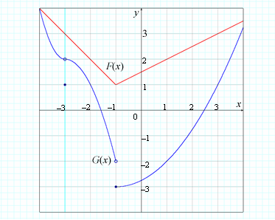

**Solution**

1. We see from the graphs of*F*and*G*that

https://content.umuc.edu/file/7bdece95-b196-4233-9313-aa904663b08e/1/MATH140-0909.zip/Modules/M2-Module_2/Lesson_3/images/limit-x-to-neg3.gif*F*(*x*) = 3 AND https://content.umuc.edu/file/7bdece95-b196-4233-9313-aa904663b08e/1/MATH140-0909.zip/Modules/M2-Module_2/Lesson_3/images/limit-x-to-neg3.gif*G*(*x*) = 2

As both limits exist, we can apply the Limit Principles:

https://content.umuc.edu/file/7bdece95-b196-4233-9313-aa904663b08e/1/MATH140-0909.zip/Modules/M2-Module_2/Lesson_3/images/limit-x-to-neg3.gif[2*F*(*x*) – 3*G*(*x*)] = https://content.umuc.edu/file/7bdece95-b196-4233-9313-aa904663b08e/1/MATH140-0909.zip/Modules/M2-Module_2/Lesson_3/images/limit-x-to-neg3.gif[2*F*(*x*)] – https://content.umuc.edu/file/7bdece95-b196-4233-9313-aa904663b08e/1/MATH140-0909.zip/Modules/M2-Module_2/Lesson_3/images/limit-x-to-neg3.gif[3*G*(*x*)] (Theorem 1 Principle 2)

= 2https://content.umuc.edu/file/7bdece95-b196-4233-9313-aa904663b08e/1/MATH140-0909.zip/Modules/M2-Module_2/Lesson_3/images/limit-x-to-neg3.gif*F*(*x*) – 3https://content.umuc.edu/file/7bdece95-b196-4233-9313-aa904663b08e/1/MATH140-0909.zip/Modules/M2-Module_2/Lesson_3/images/limit-x-to-neg3.gif*G*(*x*) (Theorem 1 Principle 5)

= 2(3) – 3(2) = 0

1. Again, by referring to the graphs of *F* and *G*, we can see that

https://content.umuc.edu/file/7bdece95-b196-4233-9313-aa904663b08e/1/MATH140-0909.zip/Modules/M2-Module_2/Lesson_3/images/limit-x-to-neg2.gif*F*(*x*) = 2 AND https://content.umuc.edu/file/7bdece95-b196-4233-9313-aa904663b08e/1/MATH140-0909.zip/Modules/M2-Module_2/Lesson_3/images/limit-x-to-neg2.gif*G*(*x*) = 1

As both limits exist, we can apply the Limit Principles:

https://content.umuc.edu/file/7bdece95-b196-4233-9313-aa904663b08e/1/MATH140-0909.zip/Modules/M2-Module_2/Lesson_3/images/limit-x-to-neg2.gif [*F*(*x*)]3 + [*G*(*x*)]2 = https://content.umuc.edu/file/7bdece95-b196-4233-9313-aa904663b08e/1/MATH140-0909.zip/Modules/M2-Module_2/Lesson_3/images/limit-x-to-neg2.gif [*F*(*x*)]3 + lim(*x→*–2) [*G*(*x*)]2 (Theorem 1 Principle 1)

= [https://content.umuc.edu/file/7bdece95-b196-4233-9313-aa904663b08e/1/MATH140-0909.zip/Modules/M2-Module_2/Lesson_3/images/limit-x-to-neg2.gif*F*(*x*)]3 + [https://content.umuc.edu/file/7bdece95-b196-4233-9313-aa904663b08e/1/MATH140-0909.zip/Modules/M2-Module_2/Lesson_3/images/limit-x-to-neg2.gif*G*(*x*)]2 (Theorem 1 Principle 7)

= (2)3 + (1)2 = 9

1. By observing the graphs of *F* and G, we can see that

https://content.umuc.edu/file/7bdece95-b196-4233-9313-aa904663b08e/1/MATH140-0909.zip/Modules/M2-Module_2/Lesson_3/images/limit-x-to-neg1.gif*F*(*x*) = 1

https://content.umuc.edu/file/7bdece95-b196-4233-9313-aa904663b08e/1/MATH140-0909.zip/Modules/M2-Module_2/Lesson_3/images/limit-x-to-neg1.gif*G*(*x*) does *not* exist

Notice that the left and right limits of *G*(*x*) are not the same as *x* approaches –1 from either side:

*G*(*x*) = –3

https://content.umuc.edu/file/7bdece95-b196-4233-9313-aa904663b08e/1/MATH140-0909.zip/Modules/M2-Module_2/Lesson_3/images/limit-x-to-1minus.gif*G*(*x*) = –2

Hence, https://content.umuc.edu/file/7bdece95-b196-4233-9313-aa904663b08e/1/MATH140-0909.zip/Modules/M2-Module_2/Lesson_3/images/limit-x-to-1minus.gif [*F*(*x*)*G*(*x*)] + 3 does *not*exist.

1. From the graphs of *F* and *G*, we observe that

*https://content.umuc.edu/file/7bdece95-b196-4233-9313-aa904663b08e/1/MATH140-0909.zip/Modules/M2-Module_2/Lesson_3/images/limit-x-to-3.gifF*(*x*) = 3 AND *https://content.umuc.edu/file/7bdece95-b196-4233-9313-aa904663b08e/1/MATH140-0909.zip/Modules/M2-Module_2/Lesson_3/images/limit-x-to-3.gifG*(*x*) = 1

As the limit of the denominator is not 0, we can apply the Quotient Principle:

https://content.umuc.edu/file/7bdece95-b196-4233-9313-aa904663b08e/1/MATH140-0909.zip/Modules/M2-Module_2/Lesson_3/images/MATH14-mod2-lessn2-ex2-3-2d-soltn.gif   (Theorem 1 Principle 4)

https://content.umuc.edu/file/7bdece95-b196-4233-9313-aa904663b08e/1/MATH140-0909.zip/Modules/M2-Module_2/Lesson_3/images/MATH14-mod2-lessn2-ex2-3-2d-soltn1.gif

Now that we understand the Limit Principles as *x* approaches a finite number *c*, we will discuss another important theorem for limits.

Theorem 2 Limit Principles (*x* approaches ±∞)

Suppose *f*(*x*) and *g*(*x*) both exist. The following then are true:

|  |  |
| --- | --- |
| 1. Sum Principle: | [*f*(*x*) + *g*(*x*)] = *f*(*x*) + *g*(*x*) |
| 2. Difference Principle: | [*f*(*x*) – g(*x*)] = *f*(*x*) – *g*(*x*) |
| 3. Product Principle: | [*f*(*x*)*g*(*x*)] = [*f*(*x*)] [*g*(*x*)] |
| 4. Quotient Principle: | https://content.umuc.edu/file/7bdece95-b196-4233-9313-aa904663b08e/1/MATH140-0909.zip/Modules/M2-Module_2/Lesson_3/images/QuotientPrinciple-infinity.gif, if *g*(*x*) ≠ 0 |
| 5. Constant Multiple Principle: | [*rf*(*x*)] = *r*[*f*(*x*)], for any constant *r* |
| 6. Constant Principle: | *r* = *r*, for any constant *r* |
| 7. Power Principle: | [*f*(*x*)]*n* = [*f*(*x*)]*n*, for any positive integer *n* |
| 8. Root Principle: | https://content.umuc.edu/file/7bdece95-b196-4233-9313-aa904663b08e/1/MATH140-0909.zip/Modules/M2-Module_2/Lesson_3/images/RootPrinciple-infinity.gif (in cases where *n*is even, we assume that *f*(*x*) > 0) |

Suppose *f*(*x*) = 1/*x*. When we consider arbitrarily large positive values of *x*, we observe that the values of *f*(*x*) approach 0 (see table 2.3.1a).

**Table 2.3.1a  
Values of *f*(*x*) with Positive Values of *x***

|  |  |
| --- | --- |
| ***x*** | ***f*(*x*) = 1/*x*** |
| 10 | 0.1 |
| 100 | 0.01 |
| 1000 | 0.001 |
| 10000 | 0.0001 |
| 100000 | 0.00001 |
| 1000000 | 0.000001 |

Similarly, when we consider arbitrarily large negative values of *x*, we observe that *f*(*x*) approaches 0 (see table 2.3.1b).

**Table 2.3.1b  
Values of *f*(*x*) with Negative Values of *x***

|  |  |
| --- | --- |
| ***x*** | ***f*(*x*) = 1/*x*** |
| –10 | –0.1 |
| –100 | –0.01 |
| –1000 | –0.001 |
| –10000 | –0.0001 |
| –100000 | –0.00001 |
| –1000000 | –0.000001 |

We can see by combining the results in tables 2.3.1a and 2.3.1b that

https://content.umuc.edu/file/7bdece95-b196-4233-9313-aa904663b08e/1/MATH140-0909.zip/Modules/M2-Module_2/Lesson_3/images/limit-x-to-infinity-1-ovr-x.gif = 0 AND https://content.umuc.edu/file/7bdece95-b196-4233-9313-aa904663b08e/1/MATH140-0909.zip/Modules/M2-Module_2/Lesson_3/images/limit-x-to-infinity-1-ovr-x.gif= 0

By combining the results stated above with Theorem 2 Limit Principles 6 and 7, we arrive at the following theorem, which is useful for computing limits at infinity.

Theorem 3

If *s* > 0 is a rational number, and *r* is any constant, then

https://content.umuc.edu/file/7bdece95-b196-4233-9313-aa904663b08e/1/MATH140-0909.zip/Modules/M2-Module_2/Lesson_3/images/Theorem3-eq.gif

provided that *xs* is defined for all *x*.

**Note This**

|  |  |
| --- | --- |
| https://content.umuc.edu/file/7bdece95-b196-4233-9313-aa904663b08e/1/MATH140-0909.zip/Modules/M2-Module_2/Lesson_3/images/NoteThisIcon.png | In general, to find the limit at infinity of any rational function, we first divide both the numerator and the denominator by the highest power of *x* in the denominator (*x* ≠ 0). |

**Exercise 2.3.3: Find Limits Using Theorem 2 Limit Principles and Theorem 3**

**Problem**

Find each of the following limits using the Theorem 2 Limit Principles and Theorem 3.

1. https://content.umuc.edu/file/7bdece95-b196-4233-9313-aa904663b08e/1/MATH140-0909.zip/Modules/M2-Module_2/Lesson_3/images/MATH14-mod2-lessn3-ex2-3-3a-prob.gif
2. https://content.umuc.edu/file/7bdece95-b196-4233-9313-aa904663b08e/1/MATH140-0909.zip/Modules/M2-Module_2/Lesson_3/images/MATH14-mod2-lessn3-ex2-3-3b-prob.gif
3. https://content.umuc.edu/file/7bdece95-b196-4233-9313-aa904663b08e/1/MATH140-0909.zip/Modules/M2-Module_2/Lesson_3/images/MATH14-mod2-lessn3-ex2-3-3c-prob.gif

**Solution**

1. Dividing both the numerator and the denominator by *x*4 (the highest power of *x* in the denominator), we obtain

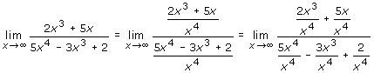

= 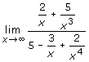

= 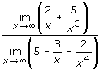 (Theorem 2 Principle 4)

= 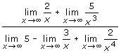(Theorem 2 Principles 1 and 2)

= https://content.umuc.edu/file/7bdece95-b196-4233-9313-aa904663b08e/1/MATH140-0909.zip/Modules/M2-Module_2/Lesson_3/images/MATH14-mod2-lessn3-ex2-3-3a-soltn4.gif(Theorem 2 Principle 6; Theorem 3)

= 0

1. Again, dividing both the numerator and the denominator by *x*5 (the highest power of *x* in the denominator), we obtain

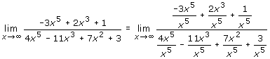

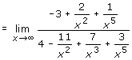

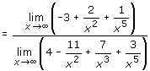(Theorem 2 Principle 4)

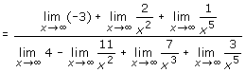 (Theorem 2 Principles 1 and 2)

https://content.umuc.edu/file/7bdece95-b196-4233-9313-aa904663b08e/1/MATH140-0909.zip/Modules/M2-Module_2/Lesson_3/images/MATH14-mod2-lessn3-ex2-3-3b-soltn5.gif (Theorem 2 Principle 6; Theorem 3)

1. Dividing both the numerator and the denominator by *x*2 (the highest power of *x* in the denominator), we obtain

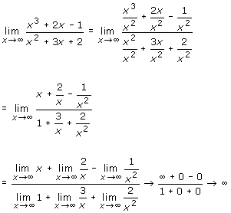

The limit becomes arbitrarily large as *x* approaches ∞.

**Exercise 2.3.4: Find the Horizontal Asymptote of a Graph**

**Problem**

Suppose https://content.umuc.edu/file/7bdece95-b196-4233-9313-aa904663b08e/1/MATH140-0909.zip/Modules/M2-Module_2/Lesson_3/images/MATH14-mod2-lessn3-ex2-3-4-prob.gif. Find the horizontal asymptote of the graph of *f*.

**Solution**

From Definition 8 in lesson 2, we know that the horizontal asymptote of the graph of *f* is determined by the following limit:

https://content.umuc.edu/file/7bdece95-b196-4233-9313-aa904663b08e/1/MATH140-0909.zip/Modules/M2-Module_2/Lesson_3/images/MATH14-mod2-lessn3-ex2-3-4-soltn.gif

To find the limit, we divide the numerator and the denominator by the highest power of *x* in the denominator (**Note:** https://content.umuc.edu/file/7bdece95-b196-4233-9313-aa904663b08e/1/MATH140-0909.zip/Modules/M2-Module_2/Lesson_3/images/sgrt-x-tothe4th.gif= *x*2 when *x* > 0).

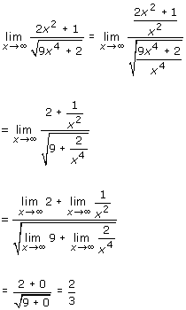

The horizontal asymptote of the graph of *f* is *y* = 2/3 (see figure 2.3.2).

**Figure 2.3.2  
Horizontal Asymptote of *y* = 2/3**

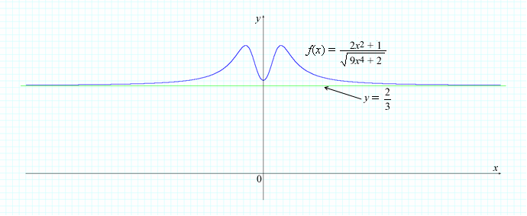

**Exercise 2.3.5: Find a Limit I**

**Problem**

Find https://content.umuc.edu/file/7bdece95-b196-4233-9313-aa904663b08e/1/MATH140-0909.zip/Modules/M2-Module_2/Lesson_3/images/limit-x-to-infinity.gif(*x*3 – 2*x*2).

**Solution**

We are *not* allowed to apply the Difference Principle in Theorem 2 to obtain https://content.umuc.edu/file/7bdece95-b196-4233-9313-aa904663b08e/1/MATH140-0909.zip/Modules/M2-Module_2/Lesson_3/images/limit-x-to-infinity.gif (*x*3 – *x*2) = https://content.umuc.edu/file/7bdece95-b196-4233-9313-aa904663b08e/1/MATH140-0909.zip/Modules/M2-Module_2/Lesson_3/images/limit-x-to-infinity.gif*x*3 – https://content.umuc.edu/file/7bdece95-b196-4233-9313-aa904663b08e/1/MATH140-0909.zip/Modules/M2-Module_2/Lesson_3/images/limit-x-to-infinity.gif*x*2 = ∞ – ∞ = ?, as *none of the limits in the difference exist*.

However, we may consider the approach of https://content.umuc.edu/file/7bdece95-b196-4233-9313-aa904663b08e/1/MATH140-0909.zip/Modules/M2-Module_2/Lesson_3/images/limit-x-to-infinity.gif(*x*3 – 2*x*2) = https://content.umuc.edu/file/7bdece95-b196-4233-9313-aa904663b08e/1/MATH140-0909.zip/Modules/M2-Module_2/Lesson_3/images/limit-x-to-infinity.gif*x*2(*x* – 2) = https://content.umuc.edu/file/7bdece95-b196-4233-9313-aa904663b08e/1/MATH140-0909.zip/Modules/M2-Module_2/Lesson_3/images/limit-x-to-infinity.gif*x*2 ● https://content.umuc.edu/file/7bdece95-b196-4233-9313-aa904663b08e/1/MATH140-0909.zip/Modules/M2-Module_2/Lesson_3/images/limit-x-to-infinity.gif(*x* – 2) = ∞, as both *x*2 and *x* – 2 become arbitrarily large as *x*approaches ∞.

**Exercise 2.3.6: Find a Limit II**

**Problem**

Find https://content.umuc.edu/file/7bdece95-b196-4233-9313-aa904663b08e/1/MATH140-0909.zip/Modules/M2-Module_2/Lesson_3/images/Math140-mo2-lessn3-ex2-3-6-prob.gif, if it exists.

**Solution**

We cannot simply apply the Difference Principle here, as both https://content.umuc.edu/file/7bdece95-b196-4233-9313-aa904663b08e/1/MATH140-0909.zip/Modules/M2-Module_2/Lesson_3/images/Math140-mo2-lessn3-ex2-3-6-soltn.gif and *x* become arbitrarily large as *x* approaches infinity. We can use the following strategy, employed to rewrite expressions involving radicals by multiplying both the numerator and the denominator by the *radical conjugate*:

https://content.umuc.edu/file/7bdece95-b196-4233-9313-aa904663b08e/1/MATH140-0909.zip/Modules/M2-Module_2/Lesson_3/images/Math140-mo2-lessn3-ex2-3-6-soltn1.gif

https://content.umuc.edu/file/7bdece95-b196-4233-9313-aa904663b08e/1/MATH140-0909.zip/Modules/M2-Module_2/Lesson_3/images/Math140-mo2-lessn3-ex2-3-6-soltn2.gif

https://content.umuc.edu/file/7bdece95-b196-4233-9313-aa904663b08e/1/MATH140-0909.zip/Modules/M2-Module_2/Lesson_3/images/Math140-mo2-lessn3-ex2-3-6-soltn3.gif

https://content.umuc.edu/file/7bdece95-b196-4233-9313-aa904663b08e/1/MATH140-0909.zip/Modules/M2-Module_2/Lesson_3/images/Math140-mo2-lessn3-ex2-3-6-soltn4.gif

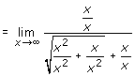 (**Note:** https://content.umuc.edu/file/7bdece95-b196-4233-9313-aa904663b08e/1/MATH140-0909.zip/Modules/M2-Module_2/Lesson_3/images/sqrt-x-sqrd.gif= *x*when *x* > 0)

https://content.umuc.edu/file/7bdece95-b196-4233-9313-aa904663b08e/1/MATH140-0909.zip/Modules/M2-Module_2/Lesson_3/images/Math140-mo2-lessn3-ex2-3-6-soltn6.gif

https://content.umuc.edu/file/7bdece95-b196-4233-9313-aa904663b08e/1/MATH140-0909.zip/Modules/M2-Module_2/Lesson_3/images/Math140-mo2-lessn3-ex2-3-6-soltn7.gif(see figure 2.3.3)

**https://content.umuc.edu/file/7bdece95-b196-4233-9313-aa904663b08e/1/MATH140-0909.zip/Modules/M2-Module_2/Lesson_3/images/MATH14-mod2-lessn3-ex2-3-3-figtitle.gif**

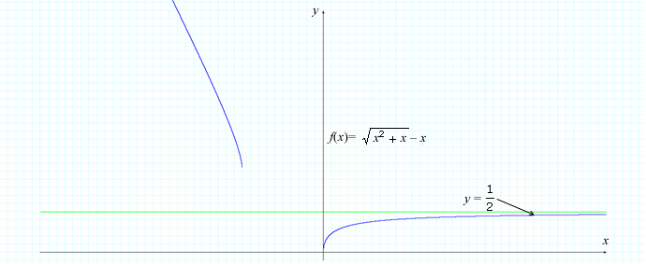

Theorem 4

If *f* is a function, then

https://content.umuc.edu/file/7bdece95-b196-4233-9313-aa904663b08e/1/MATH140-0909.zip/Modules/M2-Module_2/Lesson_3/images/limit-x-to-infinity.gif*f*(1/*x*) = https://content.umuc.edu/file/7bdece95-b196-4233-9313-aa904663b08e/1/MATH140-0909.zip/Modules/M2-Module_2/Lesson_3/images/limit-x-to-0plus.gif

AND

https://content.umuc.edu/file/7bdece95-b196-4233-9313-aa904663b08e/1/MATH140-0909.zip/Modules/M2-Module_2/Lesson_3/images/limit-x-to-neg-infinity.gif*f*(1/*x*) = https://content.umuc.edu/file/7bdece95-b196-4233-9313-aa904663b08e/1/MATH140-0909.zip/Modules/M2-Module_2/Lesson_3/images/limit-x-to-0minus.gif

provided the limits exist.

**Exercise 2.3.7: Find a Horizontal Asymptote Using Theorems**

**Problem**

The following function models the concentration of a flu vaccine in milligrams per liter in the bloodstream after *t* hours:

https://content.umuc.edu/file/7bdece95-b196-4233-9313-aa904663b08e/1/MATH140-0909.zip/Modules/M2-Module_2/Lesson_3/images/Math140-mo2-lessn3-ex2-3-7-prob.gif

Use the Theorem 2 Limit Principles to find the horizontal asymptote of the graph of *F*(*t*).

**Solution**

Looking at the graph of *F*(*t*), we observe that the horizontal asymptote is occurring with respect to the far-right behavior of the function. Therefore, we will consider only the limit of the function *F*(*t*) as *x* approaches ∞:

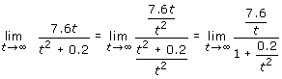

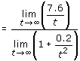 (Theorem 2 Principle 4)

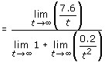(Theorem 2 Principle 1)

https://content.umuc.edu/file/7bdece95-b196-4233-9313-aa904663b08e/1/MATH140-0909.zip/Modules/M2-Module_2/Lesson_3/images/Math140-mo2-lessn3-ex2-3-7-soltn3.gif (Theorem 2 Principle 6; Theorem 3)

= 0

As time passes (*t* approaches ∞), the concentration of the flu medication in the bloodstream approaches 0. This makes sense, as the concentration of a drug in a particular location lessens over time (and we cannot have a negative concentration of a drug in the bloodstream).

**Figure 2.3.4  
*F*(*t*) with Horizontal Asymptote**

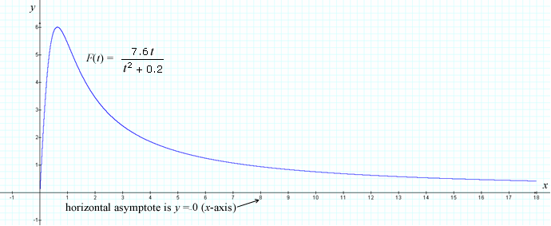

**2. Limit Theorems**

Theorem 5: Substitution Property for Polynomials

If *p*(*x*) is a polynomial, then https://content.umuc.edu/file/7bdece95-b196-4233-9313-aa904663b08e/1/MATH140-0909.zip/Modules/M2-Module_2/Lesson_3/images/limit-x-to-c.gif*p*(*x*) = *p*(*c*).

**Note This**

|  |  |
| --- | --- |
| https://content.umuc.edu/file/7bdece95-b196-4233-9313-aa904663b08e/1/MATH140-0909.zip/Modules/M2-Module_2/Lesson_3/images/NoteThisIcon.png | Polynomials have this substitution property, as they are continuous at any real number *c*—that is, they are continuous for all real numbers. We will discuss continuity in lesson 4. It is important to note that, while all polynomials have this substitution property, not all functions have it. |

**Exercise 2.3.8: Find a Limit III**

**Problem**

Find https://content.umuc.edu/file/7bdece95-b196-4233-9313-aa904663b08e/1/MATH140-0909.zip/Modules/M2-Module_2/Lesson_3/images/limit-x-to-1.gif(*x*5 + 2*x*4 + 3*x*3 + 4*x*2 + 5*x* + 6).

**Solution**

Let *p*(*x*) = *x*5 + 2*x*4 + 3*x*3 + 4*x*2 + 5*x* + 6. As *p*(*x*) is a polynomial, we can apply Theorem 5 to give us

*https://content.umuc.edu/file/7bdece95-b196-4233-9313-aa904663b08e/1/MATH140-0909.zip/Modules/M2-Module_2/Lesson_3/images/limit-x-to-1.gifp*(*x*) = *p*(1) = 1 + 2 + 3 + 4 + 5 + 6 = 21

Theorem 6 tells us that the limit of a rational function as *x* approaches *c*can also be determined by direct substitution, provided that the denominator is not 0 at *c*.

Theorem 6: Substitution Property for Rational Functions

If *p*(*x*) and *q*(*x*) are polynomials and *q*(*c*) ≠ 0, then

https://content.umuc.edu/file/7bdece95-b196-4233-9313-aa904663b08e/1/MATH140-0909.zip/Modules/M2-Module_2/Lesson_3/images/Theorem6-eq.gif

**Exercise 2.3.9: Find a Limit IV**

**Problem**

Find https://content.umuc.edu/file/7bdece95-b196-4233-9313-aa904663b08e/1/MATH140-0909.zip/Modules/M2-Module_2/Lesson_3/images/Math140-mo2-lessn3-ex2-3-9-prob.gif.

**Solution**

By taking *p*(*x*) = *x*3 – 2*x* and *q*(*x*) = *x*2 + 2 and observing *q*(–2) ≠ 0, we can apply Theorem 6 in finding the limit by directly substituting*c*= –2 into the rational function:

https://content.umuc.edu/file/7bdece95-b196-4233-9313-aa904663b08e/1/MATH140-0909.zip/Modules/M2-Module_2/Lesson_3/images/Math140-mo2-lessn3-ex2-3-9-soltn.gif

Theorem 6 works only when the denominator of the rational function is not 0 at the point *c*. Where the denominator is 0 at c, we may be able to reduce the fraction (rational function) by canceling common factors in the numerator and the denominator to form a new fraction (function) whose denominator may no longer be 0 at *c*. Theorem 6 assures us that the limit of the "new reduced" function is identical to the limit value of the original function.

Theorem 7: Equal Functions Property

If *f*(*x*) = *g*(*x*) for all *x* ≠ *a*, then lim(*x →**c*) *f*(*x*) = lim(*x*→*c*) *g*(*x*).

**Exercise 2.3.10: Find a Limit V**

**Problem**

Find https://content.umuc.edu/file/7bdece95-b196-4233-9313-aa904663b08e/1/MATH140-0909.zip/Modules/M2-Module_2/Lesson_3/images/Math140-mo2-lessn3-ex2-3-10-prob.gif, if it exists.

**Solution**

We cannot apply the Quotient Principle or Theorem 6 because the limit of the denominator is 0.

As we are considering the limit as *x* approaches 2 with *x* ≠ 2, we know that *x* – 2 ≠ 0. We can therefore cancel the common factor of *x* – 2.

According to Theorem 7, as

https://content.umuc.edu/file/7bdece95-b196-4233-9313-aa904663b08e/1/MATH140-0909.zip/Modules/M2-Module_2/Lesson_3/images/Math140-mo2-lessn3-ex2-3-10-soltn.gif, for all *x* ≠ 2

we have

https://content.umuc.edu/file/7bdece95-b196-4233-9313-aa904663b08e/1/MATH140-0909.zip/Modules/M2-Module_2/Lesson_3/images/Math140-mo2-lessn3-ex2-3-10-soltn1.gif

Theorem 8

lim(*x*→*c*) *f*(*x*) = *L* IF AND ONLY IF lim(*x*→*c+*)*f*(*x*) = *L*= lim(*x*→*c–*) *f*(*x*).

**Exercise 2.3.11: Find a Limit VI**

**Problem**

Suppose https://content.umuc.edu/file/7bdece95-b196-4233-9313-aa904663b08e/1/MATH140-0909.zip/Modules/M2-Module_2/Lesson_3/images/MATH14-mod2-lessn3-ex2-3-11-prob.gif. Find https://content.umuc.edu/file/7bdece95-b196-4233-9313-aa904663b08e/1/MATH140-0909.zip/Modules/M2-Module_2/Lesson_3/images/limit-x-to-0.gif *f*(*x*), if it exists.

**Solution**

Consider the limit of *f*(*x*) as *x*approaches 0 from the right:

https://content.umuc.edu/file/7bdece95-b196-4233-9313-aa904663b08e/1/MATH140-0909.zip/Modules/M2-Module_2/Lesson_3/images/limit-x-to-0minus.gif = 1, as *f*(*x*) = *x*2 + 1 if *x* ≥ 0

and as *x*approaches 0 from the left:

*https://content.umuc.edu/file/7bdece95-b196-4233-9313-aa904663b08e/1/MATH140-0909.zip/Modules/M2-Module_2/Lesson_3/images/limit-x-to-0minus.gif*= 1, as *f*(*x*) = *x*2 – 1 if *x* < 0

Because the left- and right-hand limits are not equal, according to Theorem 8, https://content.umuc.edu/file/7bdece95-b196-4233-9313-aa904663b08e/1/MATH140-0909.zip/Modules/M2-Module_2/Lesson_3/images/limit-x-to-0.gif *f*(*x*) does *not*exist (see figure 2.3.5):

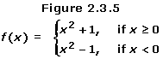

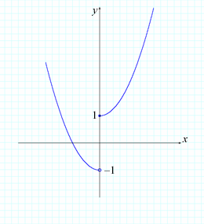

**Exercise 2.3.12: Show That a Limit Exists**

**Problem**

Show that https://content.umuc.edu/file/7bdece95-b196-4233-9313-aa904663b08e/1/MATH140-0909.zip/Modules/M2-Module_2/Lesson_3/images/limit-x-to-2.gif *g*(*x*) exists if https://content.umuc.edu/file/7bdece95-b196-4233-9313-aa904663b08e/1/MATH140-0909.zip/Modules/M2-Module_2/Lesson_3/images/MATH14-mod2-lessn3-ex2-3-12-prob.gif.

**Solution**

As https://content.umuc.edu/file/7bdece95-b196-4233-9313-aa904663b08e/1/MATH140-0909.zip/Modules/M2-Module_2/Lesson_3/images/MATH14-mod2-lessn3-ex2-3-12-soltn.gif for *x* > 2,

https://content.umuc.edu/file/7bdece95-b196-4233-9313-aa904663b08e/1/MATH140-0909.zip/Modules/M2-Module_2/Lesson_3/images/MATH14-mod2-lessn3-ex2-3-12-soltn1.gif

Also, as https://content.umuc.edu/file/7bdece95-b196-4233-9313-aa904663b08e/1/MATH140-0909.zip/Modules/M2-Module_2/Lesson_3/images/MATH14-mod2-lessn3-ex2-3-12-soltn2.giffor *x* < 2,

https://content.umuc.edu/file/7bdece95-b196-4233-9313-aa904663b08e/1/MATH140-0909.zip/Modules/M2-Module_2/Lesson_3/images/limit-x-to-2-minus.gif https://content.umuc.edu/file/7bdece95-b196-4233-9313-aa904663b08e/1/MATH140-0909.zip/Modules/M2-Module_2/Lesson_3/images/MATH14-mod2-lessn3-ex2-3-12-soltn2.gif

According to Theorem 8, because https://content.umuc.edu/file/7bdece95-b196-4233-9313-aa904663b08e/1/MATH140-0909.zip/Modules/M2-Module_2/Lesson_3/images/MATH14-mod2-lessn3-ex2-3-12-soltn4.gif, the limit exists, and

https://content.umuc.edu/file/7bdece95-b196-4233-9313-aa904663b08e/1/MATH140-0909.zip/Modules/M2-Module_2/Lesson_3/images/limit-x-to-2.gif *g*(*x*) = –1

Figure 2.3.6 shows the graph of *g*(*x*).

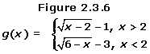

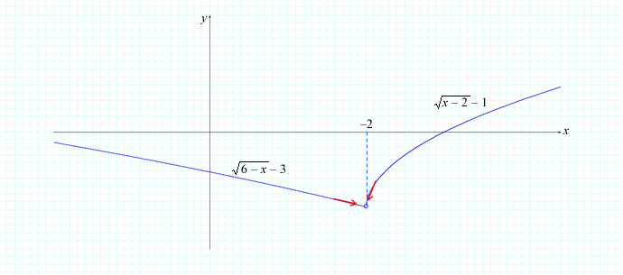

Theorem 9: Squeeze Theorem

Suppose *f*(*x*) ≤ *g*(*x*) ≤ *h*(*x*) if *x* is near *c*(except possibly at *c*). Also, suppose the limits of  *f*, *g*, and *h* exist as *x* approaches*c*, and that

https://content.umuc.edu/file/7bdece95-b196-4233-9313-aa904663b08e/1/MATH140-0909.zip/Modules/M2-Module_2/Lesson_3/images/limit-x-to-c.gif*f*(*x*) = https://content.umuc.edu/file/7bdece95-b196-4233-9313-aa904663b08e/1/MATH140-0909.zip/Modules/M2-Module_2/Lesson_3/images/limit-x-to-c.gif*h*(*x*) = *L*

Then, https://content.umuc.edu/file/7bdece95-b196-4233-9313-aa904663b08e/1/MATH140-0909.zip/Modules/M2-Module_2/Lesson_3/images/limit-x-to-c.gif*g*(*x*) = *L*.

The proof of the Squeeze Theorem relies on the precise definition of the limit. Conceptually, this theorem tells us that, if two functions *f*(*x*) and *h*(*x*) are bounding a function from below and above a function *g*(*x*) near *c*, and if *f*(*x*) and *h*(*x*) have the same limit *L* at *c*, then*g*must have the same limit *L* at *a* as do the two functions *f*and *h*. Figure 2.3.7 illustrates this concept.

**Figure 2.3.7  
Squeeze Theorem**

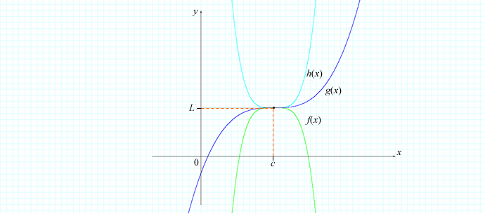

**Exercise 2.3.13: Find a Limit VII**

**Problem**

Find https://content.umuc.edu/file/7bdece95-b196-4233-9313-aa904663b08e/1/MATH140-0909.zip/Modules/M2-Module_2/Lesson_3/images/MATH14-mod2-lessn3-ex2-3-13-prob.gif, if it exists.

**Solution**

A natural, though incorrect, approach would be to apply the Product Principle:

https://content.umuc.edu/file/7bdece95-b196-4233-9313-aa904663b08e/1/MATH140-0909.zip/Modules/M2-Module_2/Lesson_3/images/MATH14-mod2-lessn3-ex2-3-13-soltn.gif

However, we cannot use the Product Principle, as https://content.umuc.edu/file/7bdece95-b196-4233-9313-aa904663b08e/1/MATH140-0909.zip/Modules/M2-Module_2/Lesson_3/images/limit-x-to-0.gifhttps://content.umuc.edu/file/7bdece95-b196-4233-9313-aa904663b08e/1/MATH140-0909.zip/Modules/M2-Module_2/Lesson_3/images/cos-sgn-1-ovr-x.gif does not exist (similar to the limit in Exercise 2.2.4 in lesson 2).

We can see in figure 2.3.8 that

–1 ≤ https://content.umuc.edu/file/7bdece95-b196-4233-9313-aa904663b08e/1/MATH140-0909.zip/Modules/M2-Module_2/Lesson_3/images/cos-sgn-1-ovr-x.gif ≤ 1 (*x* ≠ 0)

The graph of https://content.umuc.edu/file/7bdece95-b196-4233-9313-aa904663b08e/1/MATH140-0909.zip/Modules/M2-Module_2/Lesson_3/images/cos-sgn-1-ovr-x.gif always lies between –1 and 1, as we can see in figure 2.3.8:

**Figure 2.3.8  
https://content.umuc.edu/file/7bdece95-b196-4233-9313-aa904663b08e/1/MATH140-0909.zip/Modules/M2-Module_2/Lesson_3/images/Math140-mo2-lessn3-ex2-3-8-figtitle.gif**

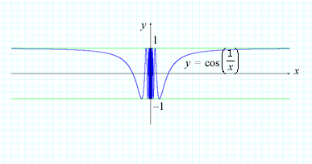

Multiplying through by *x*2 (*x*2 ≥ 0) gives us

–*x*2 ≤ *x*2 https://content.umuc.edu/file/7bdece95-b196-4233-9313-aa904663b08e/1/MATH140-0909.zip/Modules/M2-Module_2/Lesson_3/images/cos-sgn-1-ovr-x.gif ≤ *x*2

We can see this in figure 2.3.9:

**https://content.umuc.edu/file/7bdece95-b196-4233-9313-aa904663b08e/1/MATH140-0909.zip/Modules/M2-Module_2/Lesson_3/images/Math140-mo2-lessn3-ex2-3-9-figtitle.gif**

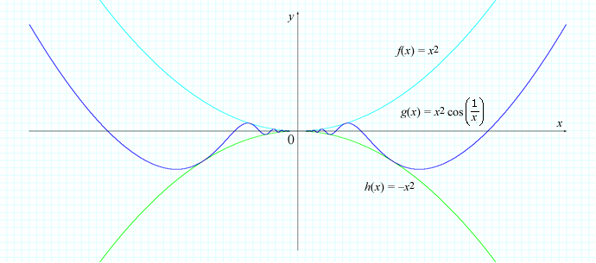

Because we know that https://content.umuc.edu/file/7bdece95-b196-4233-9313-aa904663b08e/1/MATH140-0909.zip/Modules/M2-Module_2/Lesson_3/images/limit-x-to-0.gif (–*x*2) = 0 and https://content.umuc.edu/file/7bdece95-b196-4233-9313-aa904663b08e/1/MATH140-0909.zip/Modules/M2-Module_2/Lesson_3/images/limit-x-to-0.gif*x*2 = 0, we can apply the Squeeze Theorem with *f*(*x*) = –*x*2, *g*(*x*) = *x*2 https://content.umuc.edu/file/7bdece95-b196-4233-9313-aa904663b08e/1/MATH140-0909.zip/Modules/M2-Module_2/Lesson_3/images/cos-sgn-1-ovr-x.gif, and *h*(*x*) = *x*2 to find the limit:

https://content.umuc.edu/file/7bdece95-b196-4233-9313-aa904663b08e/1/MATH140-0909.zip/Modules/M2-Module_2/Lesson_3/images/limit-x-to-0.gif*x*2 https://content.umuc.edu/file/7bdece95-b196-4233-9313-aa904663b08e/1/MATH140-0909.zip/Modules/M2-Module_2/Lesson_3/images/cos-sgn-1-ovr-x.gif = 0

[*Return to top of page*](https://content.umuc.edu/file/7bdece95-b196-4233-9313-aa904663b08e/1/MATH140-0909.zip/Modules/M2-Module_2/Lesson_3/S3-Commentary.html#pagetop)

[**Report broken links or any other problems on this page.**](http://help.umuc.edu/)  
  
[**Copyright © by University of Maryland University College.**](https://content.umuc.edu/file/7bdece95-b196-4233-9313-aa904663b08e/1/MATH140-0909.zip/common/copyright.html)